Website Analysis

Students Name
Institutional Affiliation
Course Code and Name
Instructors Name
Date
Introduction
Website analysis is a credible tool for owners and administrators. It helps them get relevant and helpful information to assist in undertaking more intricate developments on their website. Furthermore, the analysis helps web managers to enhance and fine-tune their site features. They do so to reach more users, which translates to increased monetary benefits. Website analysis is also essential in helping the site administrators, and managers resolve undesirable features and traffic unfavorable in the user interface. This report delves into an analysis of https://salts.land/ website while demystifying the site's context, usability analyses, and group action-plan analysis.
Website Context
Web context refers to the properties that define the residing objects' environment. There has been a need to ensure clean water, Viable rural ranches and communities, and natural habitats in Alberta. To steer this forward, the SALTS group was founded to ensure that landowners and the community are engaged in offering lasting and effective environmental conservation ("SALTS | Southern Alberta Land Trust Society | Alberta Conservation Association," 2021). This could not be done without a working website. The SALTS formed a website to spread its campaign for environmental conservation in Alberta. The implication of the site is to protect natural land, solicit financial support, share the organization's story and offer a platform for exploring the protected lands. The site has created areas in the web for keeping and accessing these actions about environmental conservation.
Web icon | Purpose
financial support | Solicit for donors’ funds
organization's story | Details about organization’s progresses.
maps | platform for exploring the protected lands
Sharing | Spread information about SALT
Table 1-an adaptation of https://salts.land/ web contents ("SALTS | Southern Alberta Land Trust Society | Alberta Conservation Association," 2021)
Web Usability
Web usability refers to web applications' ability to support various online tasks with satisfaction, efficiency, and effectiveness. Usability is also said to be the ease of utilizing a website. For this report, visual elements are used in the analysis of the https://salts.land/ website. This site is a beautiful website endowed with a natural land topography image. The green color of the pastures, hilly background, and dark green trees emphasizes the importance of environmental conservation. Thus, the incorporated image in the site matches with the context.
Beautiful and attractive images on the web go hand in hand with legible topographies (Ko & Liu, 2019). The website under analysis has incorporated a sizable and legible font in the entire website for easy understandability by its visitors. The subtitles on the website have a relatively larger font size. This important to the web visitors and readers as it assists them in defining information hierarchy (Soderstrom et al., 2020). Bigger fonts are more attractive than smaller ones. The implication of this is that salts.land readers will first visit important information before getting into the less important ones. Different font colors make the website attractive while reading the contents therein.
Proper Guiding of a reader from one piece of information to the other is essential. Whitespace is the one that plays this pivotal function in a website (Shenoy, 2020). For the salts.lands website, white space is applied correctly in between paragraphs to create harmony and balance. White balance in this website has played an essential role in enhancing its simplicity and eliminating unnecessary clutter. That is why the information delivered through the site is easily readable, understandable.
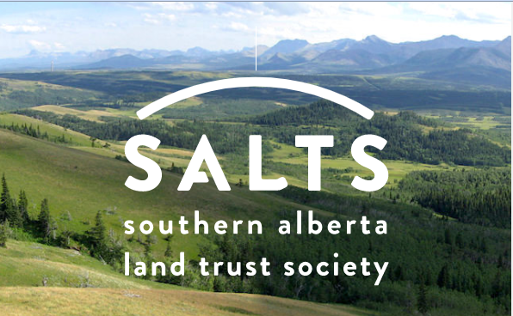
Figure-1:Natural scenery Web Image ("SALTS | Southern Alberta Land Trust Society | Alberta Conservation Association," 2021).
Group Action-Plan
This report is not conclusive as it requires further research about the Rhetoric of good professional writing while designing a website. In addition, there is also a need to delve into the macro structural/ architectural elements in the future in the analysis of websites, including the utilization of external and internal links, categories, menus, and genres.

References
Ko, C. H., & Liu, Y. C. (2019, July). User Preference of White Space in News Web Pages. In 2019 8th International Congress on Advanced Applied Informatics (IIAI-AAI) (pp. 960-965). IEEE. https://ieeexplore.ieee.org/abstract/document/8992814/
SALTS | Southern Alberta Land Trust Society | Alberta Conservation Association. Southern Alberta Land Trust Society. (2021). Retrieved 8 June 2021, from https://salts.land/.
Shenoy, A. (2020). Web Design-Peek into the Upcoming Trends in 2020. In Jumpstart UIKit (pp. 187-195). Apress, Berkeley, CA. https://link.springer.com/chapter/10.1007/978-1-4842-6029-6_6
Soderstrom, U., Carlsson, L., & Mejtoft, T. (2019, September). Comparing millennial's view on minimalism and maximalism in web design. In Proceedings of the 31st European Conference on Cognitive Ergonomics (pp. 92-95). https://dl.acm.org/doi/abs/10.1145/3335082.3335104

